SMS based voting machine

The project aims in designing a voting machine using a GSM modem. We can access the information directly on LCD display. We can implement this technology in real time. After accessing every message it automatically resets and it displays the latest message on LCD display.

In this project we make use of a LCD display, Buzzer, GSM Modem, and Micro Controller. User can send the SMS messages to the modem that is connected to the Microcontroller based control system. The microcontroller automatically reads the message that is stored in SIM card and displays on LCD display. This process continues for every new message we send to it. The previous message will be automatically overridden by new message. A buzzer alert is given for every new message displayed on LCD display.
In this project voters can be added dynamically by using EEPROM. The main advantage of this application is voting can be done from any where in the world wide using GSM and if once polling is completed the same person cannot poll again which is highly secured.
Features:
- Messages can be sent from anywhere in the world.
- GSM based communication is simple to operate.
- Low power consumption.
- Buzzer alert for every new message.

Advantages:
- User-friendly interface.
- Fast data transmission and reception.
- Low power consumption.
- Can be used by anyone who knows SMS messaging operation.

The project provides learning’s on the following advancements:
- GSM modem interfacing with controller.
- Buzzer working.
- Conversion of AC supply to DC supply.
- Embedded C programming.
- Interfacing LCD with micro controller.

The major building blocks of this project are:
- Regulated power supply
- Microcontroller
- LED indicators.
- Reset.
- Buzzer with driver.
- LCD with driver.
- Crystal oscillator.
- GSM Modem.

Software’s used:

- PIC-C compiler for Embedded C programming.
- PIC kit 2 programmer for dumping code into Micro controller.
- Express SCH for Circuit design.
- Proteus for hardware simulation.

Regulated Power Supply:
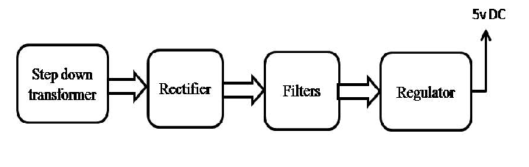

Block diagram:

