Solar based air compressor pump for car, bike tire inflate

With the existing push in the direction of sustainable, clean sources of power, it is no surprise that solar power has become one of the most popular alternative energy sources. Free and available everywhere, the power of the sun can be employed to power everything like cell phones and motors. The sun's energy is usually harvested through solar panels that are made up of photovoltaic cells. These cells can convert the sun's power into electricity that can be used for a number of purposes. For private use, a handheld solar hybrid charger can be employed to recharge little device for instance a DC fan, a cell phone, or a camera.

This project consists of Microcontroller based control unit that continuously monitors and controls the air compressor. This air compressor can be controlled using control buttons and the status of the compressor is displayed on LCD display in real time. Regulated output of Solar cell is connected to rechargeable battery through a unidirectional current flow circuitry. This particular charged battery output given as input to the air compressor motor, this motor will controlled by the user manually using control buttons and also automatically by micro controller by a set point.

In this project micro controller has the input modules like compressor sensor, control buttons and output modules are LCD display, compressor switching driver.

The objectives of the project include:
- Dynamic tire compressor setting.
- Usage of Solar energy.
- Continuous monitoring of status of air compressor on LCD.
- Manual controlling using buttons.

The project provides scope for learning the following technologies:
- Air compressor characteristics.
- Interfacing air compressor to Microcontroller.
- Solar energy.
- Embedded ‘C’ programming.

The major building blocks of this project are:
- Regulated Power supply.
- Microcontroller.
- LED Indicators.
- LCD display unit.
- Relay circuit.
- Solar panel.

Software’s used:

- PIC-C compiler for Embedded C programming.
- PIC kit 2 programmer for dumping code into Micro controller.
- Express SCH for Circuit design.
- Proteus for hardware simulation.

Regulated power supply:
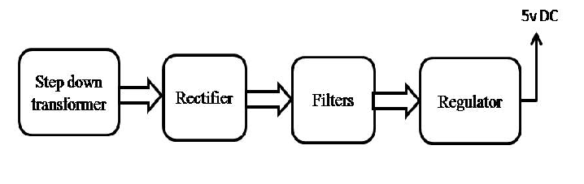

Block Diagram:

