Ultrasonic Spectacles and Waist-belt for Visually Impaired and Blind people

The main aim of the project is to design a voice based alerting system for the blind people based on servomotor and ultrasonic distance sensor for obstacle detection and voice circuit for voice based announcements. The advantage of this device is voice based announcement for easy navigation i.e. the user gets the voice which pronounces the directions he needs to move to reach his destination.

Ultrasonic Sensor senses the obstacles in its path by continuously transmitting the ultrasonic waves. If any obstacle comes in its vicinity then the ultrasonic waves get reflected back to the system. The ultrasonic receiver senses these ultrasonic waves and this information are passed to the Microcontroller. The microcontroller gives alerts through voice message

When the blind person wears this ultrasonic spectacles and waist-belt at stomach or at head, which consists of ultrasonic distance sensor. Ultrasonic distance sensor, which is capable of detecting obstacles in its path of a blind person, senses the obstacles. This information is passed to the microcontroller which then alerts the user through voice circuit in case of any obstacles in that particular direction, which helps the user to avoid obstacles in its way.

The controlling device of the whole system is a Microcontroller. The user gets alerts through ultrasonic distance sensor and voices using voice circuit. The ultrasonic distance sensor and voice circuit interfaced to Microcontroller. This system is very helpful for blind people. The Microcontroller is programmed using Embedded C language

The main features of this project are:
- Voice based alerts.
- Obstacle detection.

This project provides learning’s on the following advancements:
- Interfacing obstacle sensor to Microcontroller.
- Voice circuit.
- Interfacing voice circuit to Microcontroller.
- Embedded C programming.
- PCB designing.

The major building blocks of this project are:

- Regulated Power Supply
- Microcontroller.
- Crystal Oscillator
- Reset button
- Voice circuit.
- Ultrasonic distance sensor.
- Buzzer.
- LED indicator

Software used:

- PIC-C compiler for Embedded C programming.
- PIC kit 2 programmer for dumping code into Micro controller.
- Express SCH for Circuit design.
- Proteus for hardware simulation.

Regulated Power Supply:

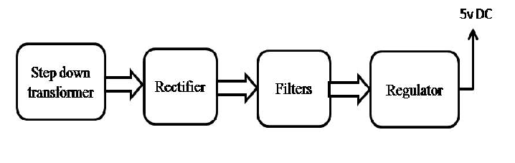
Block diagram:

