Selective Device Activation for Power Reduction in Accelerometer - Based Wearable Guidance for the Blind

The main aim of this project is to design and construct a gesture controlled device switching system for physically challenged and for blind people. The user can wear this device to any movable body and with the simple body movement’s he can request the basic needs like water, food or medicine by using MEMS (Micro Electro-Mechanical Systems) technology. User can also control the electrical devices like light; fan etc with the help of gestures.

MEMS is a Micro Electro Mechanical Sensor which is a highly sensitive sensor and capable of detecting the tilt. This sensor finds the tilt and operates the electrical devices and announces the basic needs depending on tilt. For example if the tilt is to the forward then the device will be “ON” for the first time then next time it will be “OFF”. In the same way, if the tilt is to the left side then another device is going to be controlled. The tilt is in left side or right side direction the related need will be announced. This device is very helpful for paralysis and physically challenged persons and for blind people.

This device is portable and this system operation is entirely driven by wireless technology. User can wear it to his any body movement like a band and can operate it by tilting the MEMS sensor.

This project makes use of a Relay for switching the devices and APR-9600 voice chip for audio announcements and Micro controller, which is programmed, with the help of embedded C instructions. This microcontroller is capable of communicating with transmitter and receiver modules. The MEMS based sensor detects the tilt and provides the information to the microcontroller (on board computer) and the controller judges whether the instruction is right movement or left movement instruction and controls the operation respectively.
The main objectives of the project are:
- Simple gesture based operation.
- Voice announcement of needs.
- Wireless data transmission.

This project provides us with the learning’s on the following aspects:
- Characteristics of MEMS
- Interfacing MEMS with Microcontroller.
- Interfacing the wireless communication modules.
- Appliances interfacing with the controller.
- Embedded C programming.
- PCB Design concepts.
- APR 9600-voice circuit.
The major building blocks of this project are:
- Regulated power supply.
- Microcontrollers.
- Crystal Oscillator.
- MEMS Accelerometer based sensor.
- RF transmitter and receiver modules.
- Encoder and Decoder.
- Voice circuit.
- Electromagnetic Relay.
- Reset.
- LED indicators.
Software’s used:
- PIC-C compiler for Embedded C programming.
- PIC kit 2 programmer for dumping code into Micro controller.
- Express SCH for Circuit design.
- Proteus for hardware simulation.

Regulated Power Supply:
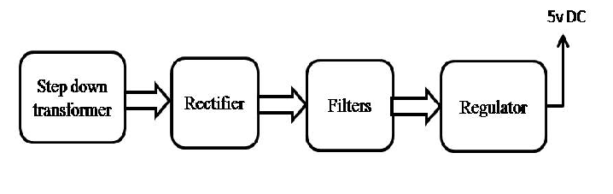
Block diagram:

