Real-time home automation based on GSM and wireless Zigbee

The project aims in designing a centralized system for an apartment building through which the electrical appliances in the flats can be monitored and controlled. Each flat owner is assigned a password to monitor or control electrical appliances of his flat through this centralized system. This maintains the privacy.

This system consists of a GSM modem to which flat owners need to send SMS in predefined format to monitor or control electrical appliances of his flat, Zigbee module for wireless transmission of data to control appliances in the flat, Relay and Triac were connected to electrical appliances that are to be controlled.

The controlling device of the whole system is a Microcontroller. This system consists of a Microcontroller in the centralized system to which GSM modem, LCD and Zigbee are interfaced. In each individual flat, a Microcontroller is present to which the electrical appliances to be controlled are interfaced through switches and also a Zigbee which receives or sends the data related to control or status of appliances. Whenever the house owner sends an SMS to the predefined number in GSM modem present at centralized system, in predefined format along with password assigned to him, then the controller validates this SMS and sends this information to the Zigbee module of respective flat. The Microcontroller in the flat process the received information ad acts appropriately on the electrical appliances.

To perform this task the Microcontroller is programmed using Embedded C language.
The main objectives of this project are:

- Remote controlling and monitoring of electrical appliances in the flat.
- Centralized system for whole apartment building.
- Wireless transmission for all the flats.
The project provides the following learning’s:

- Zigbee technology.
- GSM technology.
- Serial communication protocols.
- Microcontroller.
- Relay and Triac.
- Embedded C language.

The main building blocks of the project are:

- Regulated Power Supply.
- Microcontroller.
- GSM modem.
- Zigbee module.
- Relay.
- Triac.
- LCD display.
- Crystal oscillator.
- LED indicators.

Software used:

- PIC-C compiler for Embedded C programming.
- PIC kit 2 programmer for dumping code into Micro controller.
- Express SCH for Circuit design.
- Proteus for hardware simulation.

Regulated Power Supply:

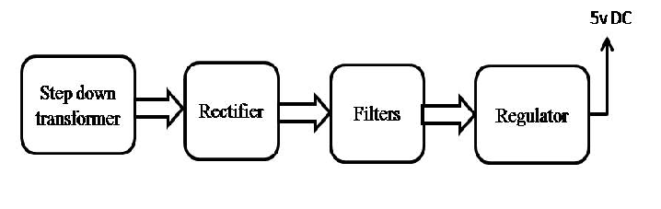
Block diagram:

