An Embedded Real-Time Finger-Vein Recognition System for Mobile Devices

In this project, we propose a real-time embedded finger-vein recognition system for authentication on mobile devices. The system is implemented on an embedded platform and equipped with a novel finger-vein recognition algorithm. The proposed system consists of three hardware modules: image acquisition module, embedded main board, and human machine communication module. The structure diagram of the system is 1. The image acquisition module is used to collect finger-vein images. The Embedded main board including the Microcontroller chip, memory (flash), and communication port is used to execute the finger-vein recognition algorithm and communicate with the peripheral device. The human machine communication module (LED or keyboard) is used to display recognition results and receive inputs from users.

The project mainly aims in designing a completely automated security access system for domestic and industrial applications. Security is the bigger concern for an individual or a firm. Recognizing the need of security we developed an automated security access system with user friendly access using finger print sensor module

The sensor is a solid-state fingerprint sensor that reliably captures fingerprint information. It is designed to integrate into devices for improved security and convenience. The sensor provides a reliable, quick and user-friendly alternative to passwords, Pin’s and other forms of user authentication.

We make use of this device to construct an automatic security access control system. The decisions like opening or closing of an AC, Boss will use device one. Depending on his finger prints and password only that AC will be working like closing and opening. In the case of manager device two will be working by using his finger prints. Same as like in employee’s case device three and four will be working depending on there finger prints and the door are taken by an onboard computer to which the finger print module is interfaced. The doors of the industry form the output module and are interfaced to the same onboard computer.

This onboard computer consists of number of input and output ports. The onboard computer is commonly termed as micro controller. The input and output port of the micro controller are interfaced with different input and output modules depending on the requirements. In other words micro controller acts as a communication medium for all the modules involved in the project.

Features:

- The finger-vein is a promising biometric pattern for personal identification in terms of its security and convenience.
- The vein is hidden inside the body and is mostly invisible to human eyes, so it is difficult to forge or steal
- The non-invasive and contact less capture of finger-veins ensures both convenience and hygiene for the user, and is thus more acceptable
- The finger-vein pattern can only be taken from a live body. Therefore, it is a natural and convincing proof that the subject whose finger-vein is successfully captured is alive.

Applications:
- ATM and Credit card
- Electronic passport
- Airport

This project provides exposure to the following technologies:

- Finger print module.
- Interfacing finger print module and microcontroller.
- Embedded C programming for microcontroller.
- Design of PCB.
The major building blocks of this project are:

- Regulated power supply with voltage regulator.
- Finger print module.
- Microcontroller.
- LED Indicators.

Software used:

- PIC-C compiler for Embedded C programming.
- PIC kit 2 programmer for dumping code into Micro controller.
- Express SCH for Circuit design.
- Proteus for hardware simulation.

Regulated power supply:

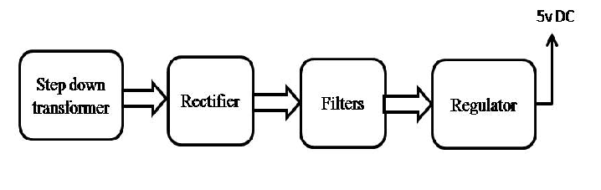
Block Diagram:

