An Accelerometer-Based Digital Pen with a Trajectory Recognition Algorithm for Handwritten Digit and Gesture Recognition

The project aims is to design an accelerometer- based digital pen with a trajectory recognition algorithm for handwritten digit and gesture recognition by using Zigbee technology. This system uses a MEMS device for having all directions.

ZigBee is a wireless technology developed as an open global standard to address the unique needs of low-cost, low-power wireless M2M networks. The ZigBee standard operates on the IEEE 802.15.4 physical radio specification and operates in unlicensed bands including 2.4 GHz, 900 MHz and 868 MHz’s. ZigBee devices have the ability to form a mesh network between nodes. Meshing is a type of daisy chaining from one device to another. This technique allows the short range of an individual node to be expanded and multiplied, covering much larger area

MEMS is a Micro Electro Mechanical Sensor which is a highly sensitive sensor and capable of detecting the tilt. This device is portable and this system operation is entirely driven by Micro controller and this microcontroller consists of a controller interfaced with MEMS Accelerometer sensor technology to control the direction of the user and user can wear it to his wrist like a watch and can operate it by tilting the MEMS Accelerometer sensor.

In this system, MEMS is the main important device which is used to monitoring the handwritten digital and gesture recognition. Its mainly depends on the four directions of the hand gestures like, left, right , upward and downward directions. In the case of left or right directions alphabets will be scrolling on the LCD and in the case of downward direction the letters will be selected and in the case of upward direction string will be placed.
The device consists of two microcontrollers, one is interfaced to Zigbee and MEMS accelerometer sensor input modules and other controller interfaced with Zigbee and LCD display unit. So the controller can be termed as a control unit. The input module is nothing but a MEMS accelerometer sensor, which takes the input from the user and provides the same to the microcontroller. Microcontroller will send the information to Zigbee module. The output module is the LCD which displays the selected data on it. Here the microcontroller receives the input from the gestures based MEMS accelerometer sensor and the selected data is displayed on LCD in digital format.

This system also transmits this information through Zigbee module, which is received by the receiver section present and displays on the LCD. Here the Microcontroller is programmed in Embedded C programming language to work according to the User requirements.

Advantages:

- Low power consumption.
- Helps for physically disabled persons
- Gestures based digital pen design
- Wireless communication using zigbee technology
- Visual display of the data on LCD
- Efficient design.
- No need for training.
- Long life.

The features of this project are:
- Decreases hardware complexity.
- Displays on LCD.
- Uses only one Hand gesture.
- Zigbee based wireless technology.

The project provides learning’s on this following advancements:

- Using MEMS Accelerometer.
- Interfacing LCD display.
- Wireless data transmission using zigbee technology.
- Conversion of AC supply to DC supply.
- Programmatically initializing the ADC module.
- Embedded C programming.
- PCB designing.

The major building blocks of this project are:

- Regulated power supply.
- MEMS Accelerometer.
- Microcontroller.
- LCD driver.
- Buzzer
- Zigbee modules
- Crystal oscillator.
- Reset.
- LED indicators

Software’s used:

- PIC-C compiler for Embedded C programming.
- PIC kit 2 programmer for dumping code into Micro controller.
- Express SCH for Circuit design.
- Proteus for hardware simulation.

Regulated Power Supply:

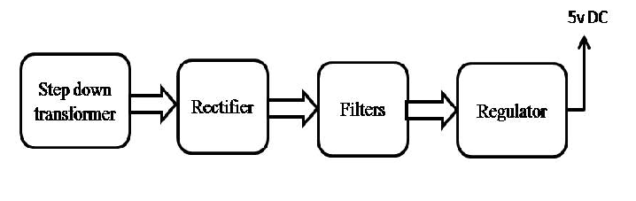

Block diagram:

