Android speech recognition controlled intelligent wheel chair

The project aims in designing a wheel chair that can be operated using Android mobile phone. The controlling of the wheel chair is done wirelessly through speech recognition application present in Android smart phone and by using the Bluetooth feature present in it. Here in the project the Android smart phone is used as speech based remote control for operating the wheel chair.

Speech technology and systems in human computer interaction have witnessed a stable and remarkable advancement over the last two decades. Today, speech technologies are commercially available for an unlimited but interesting range of tasks. These technologies enable machines to respond correctly and reliably to human voices, and provide useful and valuable services. Recent research concentrates on developing systems that would be much more robust against variability in environment, speaker and language

Android is a software stack for mobile devices that includes an operating system, middleware and key applications. Android boasts a healthy array of connectivity options, including Wi-Fi, Bluetooth, and wireless data over a cellular connection (for example, GPRS, EDGE (Enhanced Data rates for GSM Evolution), and 3G). Android provides access to a wide range of useful libraries and tools that can be used to build rich applications. In addition, Android includes a full set of tools that have been built from the ground up alongside the platform providing developers with high productivity and deep insight into their applications.

Bluetooth is an open standard specification for a radio frequency (RF)-based, short-range connectivity technology that promises to change the face of computing and wireless communication. It is designed to be an inexpensive, wireless networking system for all classes of portable devices, such as laptops, PDAs (personal digital assistants), and mobile phones. It also will enable wireless connections for desktop computers, making connections between monitors, printers, keyboards, and the CPU cable-free.

The controlling device of the whole system is a Microcontroller. Bluetooth module, DC motors are interfaced to the Microcontroller. The data received by the Bluetooth module from speech recognition application in Android smart phone is fed as input to the controller. The controller acts accordingly on the DC motors of the Wheel chair. The wheel chair in the project can be made to move in all the four directions using the Android phone. The direction of the wheel chair is indicated using LED indicators. In achieving the task the controller is loaded with a program written using Embedded ‘C’ language.

The main objectives of the project are:

- Operating the wheel chair wirelessly through mobile phone.
- Usage of speech recognition application in android smart phone in performing the task.
- Bluetooth wireless transmission.
- Indicating wheel chair directions using LED indicators.

The project provides exposure to following technologies:

- Google’s Android Open Source Technology.
- Bluetooth wireless technology.
- Interfacing Bluetooth module to Microcontroller.
- DC motor working principle and need for a motor driver.
- Interfacing of DC motors to Microcontroller.
- Embedded C programming.
- PCB designing.

The major building blocks of the project are:

- Regulated Power Supply.
- Microcontroller.
- Android smart phone.
- Bluetooth module.
- DC motors with driver.
- Crystal oscillator.
- Reset.
- LED indicators.

Software used:

- PIC-C compiler for Embedded C programming.
- PIC kit 2 programmer for dumping code into Micro controller.
- Express SCH for Circuit design.
- Proteus for hardware simulation.

Regulated Power Supply:

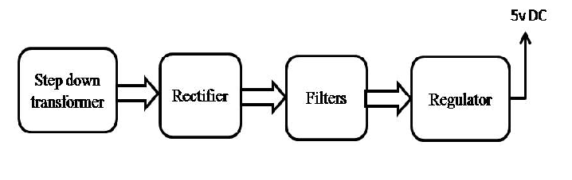

Block diagram:
