REALTIME PANTRY MENU INFORMATION SYSTEM USING ZIGBEE

The main aim of the project is to design a system for pantry updating using wireless communication. In this project the microcontroller which forms the heart of the project, plays an important role in establishing communication between transceivers. The microcontroller communicates with Zigbee transceiver and sends the data to the corresponding transceiver.

This project consists of two sections one is hand held device section and other is main section. Both sections consist of Zigbee transceivers. From the first section menu should taken and send to the ZigBee which was presents at the pantry section. Here LCD is used to display the data on LCD along with buzzer alert at the pantry section end. From the pantry section the cooking person should send accept or not availability of requested food item. Then the requested user will get the conformation for his request.

ZigBee is a wireless technology developed as an open global standard to address the unique needs of low-cost, low-power, wireless sensor networks. Zigbee is the set of specs built around the IEEE 802.15.4 wireless protocol. As Zigbee is the upcoming technology in wireless field, we had tried to demonstrate its way of functionality and various aspects like kinds, advantages and disadvantages using a small application of controlling the any kind of electronic devices and machines. The Zigbee technology is broadly adopted for bulk and fast data transmission over a dedicated channel.

The features of the project are:
- Very useful even for Passengers in train.
- Faster and secure data transmission.
- User friendly and easy to install.
- Helpful in abroad to express user’s needs.
- Fast acknowledgement.
- Buzzer indication.

This project provides us with the learning’s on the following aspects:

- Interfacing Keypad module with Microcontroller.
- LCD Interfacing with Microcontroller.
- Zigbee communication.
- Embedded C programming.
- PCB designing.
The major building blocks of this project are:
- Regulated Power Supply.
- Microcontrollers.
- Keypad
- LCD with Driver.
- Crystal Oscillator.
- Zigbee modules.
- LED Indicators.
- Buzzer with driver.
Software used:
- PIC-C compiler for embedded C programming.
- PIC kit 2 programmer for dumping code into Microcontroller.
- Express SCH for Circuit design.
- Proteus for hardware simulation.

Regulated power supply:

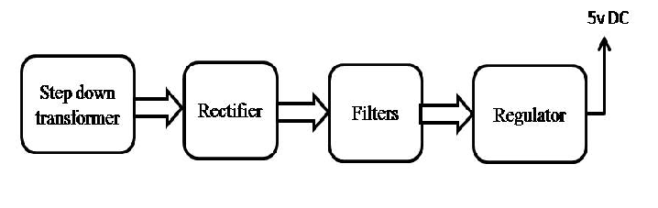
Block Diagram:
