Dual Security Access Control System Using Finger Print and Secure Password for Bank (door) Locker

The project mainly aims in designing a completely automated security access system for domestic and industrial applications. Security is the bigger concern for an individual or a firm. Recognizing the need of security we developed an automated security access system with user friendly access using finger print sensor module.

The sensor is a solid-state fingerprint sensor that reliably captures fingerprint information. It is designed to integrate into devices for improved security and convenience. The sensor provides a reliable, quick and user-friendly alternative to passwords, PIN's and other forms of user authentication.

We make use of this device to construct an automatic security access control system. The decisions like opening or closing the door are taken by an onboard computer to which the finger print module is interfaced. The doors of the house/industry form the output module and are interfaced to the same onboard computer.

This onboard computer consists of number of input and output ports. The onboard computer is commonly termed as micro controller. The input and output port of the micro controller are interfaced with different input and output modules depending on the requirements. In other words micro controller acts as a communication medium for all the modules involved in the project.

The device also consists of LCD which displays the information about doors open and close.

Features:

- Real time authentication system using finger print module.
- Keypad based additional security feature.
- Low power consumption.
- Long life.
- Displaying the door status (close/open)
- Highly sensitive.

This project provides exposure to the fallowing technologies:

- Finger print module.
- Interfacing finger print module and microcontroller.
- Embedded C programming for microcontroller.
- Design of PCB.
- LCD interfacing and programming.

The major building blocks of this project are:

- Regulated power supply.
- Finger print module.
- Microcontroller.
- LCD.
- LED Indicators.
- Stepper motor with driver.
- Crystal oscillator.

Software’s used:

- PIC-C compiler for Embedded C programming.
- PIC kit 2 programmer for dumping code into Micro controller.
- Express SCH for Circuit design.
- Proteus for hardware simulation.

Regulated power supply:

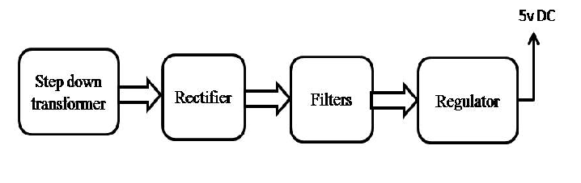

Block Diagram:

