Protection of power transformer using microcontroller-based relay

The main aim of this project is to design a tripping system which helps the power transformer from damage due to over loading. The tripping of the transformer is done through a relay switch automatically with the help of the intelligent device “Microcontroller”.

At the heart of a linear power supply is the transformer, or power transformer as it is usually known. This takes the AC mains (wall) supply voltage and converts it into one or more AC voltages that are more convenient for our needs. But, Industrial instruments failures have many causes and one of the main causes is over load. If the current flowing through that instrument is more than the rated current, then immediately the System may burn because of over load, through this project we are going to protect the transformer from over load condition.

The controlling device of the whole system is a Microcontroller. The load connected to transformer is continuously monitored by the microcontroller with the help of CT (Current Transformer) input to it. The Microcontroller takes the decision of tripping the transformer according to the load value given in the program. The tripping is done through a Relay switch. To perform the intelligent task, Microcontroller is loaded with intelligent program written using embedded ‘C’ language.

Features:

- Microcontroller based system for continuous load monitoring.
- Automated tripping system in case of over load.
- Low cost and efficient device construction.

This project provides exposure to the following technologies:

- Transformer types and principles of operation.
- Interfacing Current transformer to Microcontroller.
- Embedded C programming.
- Design of PCB.
- LCD interfacing.

The major building blocks of this project are:

- Regulated Power Supply
- Microcontroller.
- LCD display with driver.
- Current transformer.
- Relay with driver.
- Crystal oscillator.
- Reset.
- LED indicators.

Software used:

- PIC-C compiler for Embedded C programming.
- PIC kit 2 programmer for dumping code into Micro controller.
- Express SCH for Circuit design.
- Proteus for hardware simulation.

Regulated Power Supply:

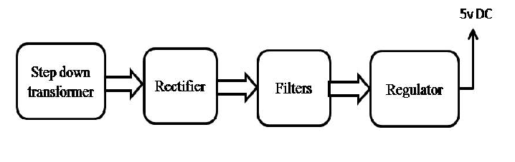

Block diagram:

