RFID based vehicle tracking and accident notification

The Main aim of the project is to design a system which is capable of tracking vehicles location wirelessly with displaying the location number on LCD based on RFID technology. Now a day’s technology is running with time, it completely occupied the life style of human beings. It is being used everywhere in our daily life to fulfil our requirements. We can not only increase the speed of life but also increase security with good ideas by making use of advanced technology.

Automation is the most frequently spelled term in the field of electronics. The hunger for automation brought many revolutions in the existing technologies. One among the technologies which had greater developments is RF communications. The result of this is the RFID cards which transmit a unique identification number. This number transmitted by the RFID can be read with the help of a RF reader.

The project makes use of a microcontroller, which acts as a central controlling unit. This module is capable of communicating with the input and the output modules. The vehicle is equipped with a system which has a RF reader, GSM modem. Different locations are equipped with RFID tags. Whenever the vehicle enters a location, the RF reader in the vehicle decodes the RFID tag of that location and displays that location name on LCD. Also, whenever an SMS is sent to the system in vehicle, it replies back with the location name. The action of these Instructions is already loaded into the Microcontroller using Embedded C programming. The intelligent control software, which has been developed Embedded C programming language.

The objectives of the project include:

- Identification of vehicle location using RFID technology.
- Real time vehicle location tracking through SMS.

The project focuses on the following advancements:

- RFID reader and RFID tag.
- RF reader interfacing with Microcontroller.
- LCD display interfacing with Microcontroller.
- Embedded C programming.
- PCB designing.

The major building blocks of this project are:

- Regulated Power Supply
- RFID reader
- RFID tags
- Micro Controller
- Crystal oscillator.
- Reset
- LCD display with driver.
- LED indicators

Software used:

- PIC-C compiler for Embedded C programming.
- PIC kit 2 programmer for dumping code into Micro controller.
- Express SCH for Circuit design.
- Proteus for hardware simulation.

Regulated Power Supply:

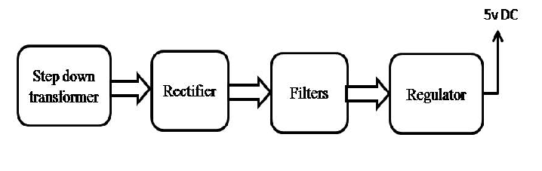
Block diagram:

