A multi agent multi sensor based security system for intelligent building

The project aims at designing an automated and intelligent home automation and security system. The proposed system is capable of automatically maintaining the temperature inside a room, alerts when any one opens doors or windows (security alert), alerts regarding smoke, automatic outside lighting depending on light level, Door switch based inside lighting and provision for enabling or disabling the alerts.

Automation is the most frequently spelled term in the field of electronics. The hunger for automation brought many revolutions in the existing technologies. The home automation techniques employed must be economic and simple to use. By analyzing all the these, this advanced home automation is proposed.

The device consists of a microcontroller, which is interfaced with the input and output modules, the controller acts as an intermediate medium between both of them. So the controller can be termed as a control unit. The Microcontroller accepts input from different modules and processes the data and acts accordingly on the output modules. The Microcontroller is loaded with an intelligent program written using embedded ‘C’ language.

Features:

- Maintaining temperature in the room according to user wish.
- Alerts regarding smoke.
- Alerts regarding thieves.
- Automated outside lighting depending on the outside light.
- Automated inside lighting through door switch.
- Provision for switching OFF inside lighting.
- Provision for enabling or disabling security.
- Provision for disabling smoke alerts
- Auto switching OFF of all systems during security alert.
- Buzzer based alerts.
- LCD display to show different operations.

This project provides exposure to the following technologies:

- Characteristics of temperature, smoke, LDR (Light Dependent Resistor) sensors.
- Working principle of relays.
- Construction of IR module.
- Interfacing of different sensors to Microcontroller.
- LCD display interfacing to Microcontroller
- Embedded ‘C’ programming.

The major building blocks of this project are:

- Regulated power supply.
- Microcontroller.
- Relays with driver.
- Buzzer with driver.
- Fan.
- LCD with driver.
- Temperature sensor.
- Potentiometer.
- Smoke sensor.
- LDR (Light Dependent Resistor).
- Switches.
- IR module
- Crystal oscillator.
- LED indicators.
Software used:

- PIC-C compiler for Embedded C programming.
- PIC kit 2 programmer for dumping code into Micro controller.
- Express SCH for Circuit design.
- Proteus for hardware simulation.

Regulated Power Supply:

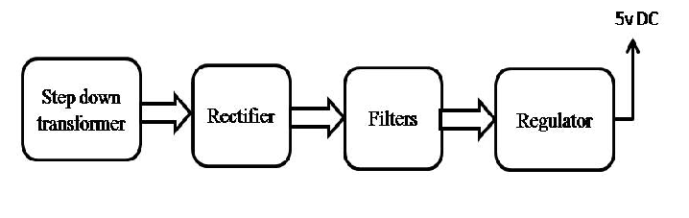

Block diagram:
