Hall-effect sensor based non-contact AC motor speed monitoring and display system with high and low speed alerts.

The purpose of this project is to design and construct a non-contact type of Tachometer. A tachometer (also called a revolution-counter, rev-counter, or RPM gauge) is an instrument that measures the rotation speed of a shaft or disk, as in a motor or other machine. Hall Effect sensors typically use a rotating target attached to a wheel, gearbox or motor. This target may contain magnets, or it may be a toothed wheel. The teeth on the wheel vary the flux density of a magnet inside the sensor head.

This project consists of a Hall effect sensor connected to a microcontroller unit. The sensor signals from Hall effect sensor are sent to microcontroller for rpm measurement. These measured final values are displayed on a LCD display connected to microcontroller.
A Hall Effect sensor is a transducer that varies its output voltage in response to changes in magnetic field. Hall sensors are used for proximity switching, positioning, speed detection, and current sensing applications.
In its simplest form, the sensor operates as an analogue transducer, directly returning a voltage. With a known magnetic field, its distance from the Hall plate can be determined. Using groups of sensors, the relative position of the magnet can be deduced.
Electricity carried through a conductor will produce a magnetic field that varies with current, and a Hall sensor can be used to measure the current without interrupting the circuit. Typically, the sensor is integrated with a wound core or permanent magnet that surrounds the conductor to be measured.
The major building blocks of this project are:
- Regulated power supply.
- Microcontroller.
- Hall Effect Sensor.
- LED indicators.
- LCD interfacing.
- LCD Display

Regulated power supply:

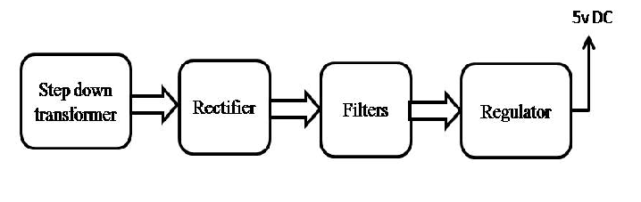

www.mycollegeproject.com www.sooxma.com

Block diagram:

