4-wired resistive touch screen controlled lamp dimmer for next generation apartments with Optical isolation and zero crossing detectors
The project aims in designing a system which helps in increasing or decreasing lamp intensity as required with simple touch. As the world gets more and more technologically advanced, we find new technology coming in deeper and deeper into our personal lives even at home. Home automation is becoming more and more popular around the world and is becoming a common practice.
The process of home automation works by making everything in the house automatically controlled using technology to control and do the jobs that we would normally do manually. It is much easier to install home automation in a house while it is still being built, since you have the ability to put things inside the walls to save space. Though, people who have houses already built can still have home automation done in a less intrusive ways.
The aim of this project is to build a Graphical LCD Touch Screen interface for high voltage electrical lamp dimming operation over wireless. The program running inside microcontroller can develop a virtual on screen keypad and a control panel. The status of lamp intensity can be viewed on Graphical LCD. No need to have mechanical rotational based control system or push buttons for this operation. Users can control the lamp intensity with gentle finger touch.
A Triac and optically isolated Diac (triac driver) based circuit controls the intensity of the high voltage 230volts lamp. This system also employs a zero crossing detector for smooth operation of lamp intensity. This project consists of a Microcontroller that takes input from touch screen over wireless and processes the request. Then it processes the data and takes necessary action and updates the status on Graphical LCD. The optical isolation system safeguards the microcontroller-based system from high voltages.
User can simply set the desired intensity with a gentle touch on touch screen. This system also provides security authentication to access this system. User has to enter the password to get access this system.

Features:

- Aims at energy conservation.
- Provides user friendly graphical interface.
- Provides fast access to using touch screen.
- Device enable with zero crossing detector.

The project provides learning’s on the following advancements:

- Characteristics of touch screen sensor.
- Interfacing touch screen sensor.
- Lamp dimmer circuitry.
- Conversion of AC supply to DC supply.
- LCD.
- RF communication.
- Embedded C programming.
- PCB designing.

The major building blocks of this project are:
- Regulated Power Supply.
- Microcontroller.
- Triac with driver
- Crystal Oscillator.
- RF transmitter.
- RF receiver.
- Reset.
- Touch Screen with driver.
- LCD with driver.
- LED Indicators

Software used:

- PIC-C compiler for Embedded C programming.
- PIC kit 2 programmer for dumping code into Micro controller.
- Express SCH for Circuit design.
- Proteus for hardware simulation.

Regulated Power Supply:

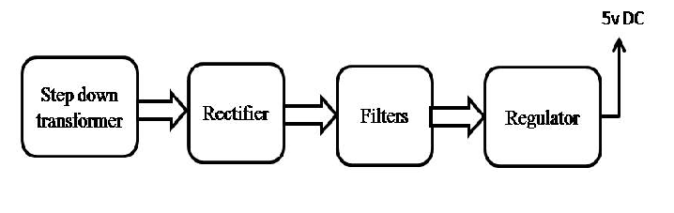

Block diagram:

