Smart card based Security Access Control System

The project mainly aims in designing a completely automated security access system for domestic and industrial applications. Security is the bigger concern for an individual or a firm. Recognizing the need of security we developed an automated security access system with user friendly access.

Over the past few years, smart cards have achieved a growing acceptance as a powerful tool for security, identification, and authorization. Financial card issuers are moving to replace magnetic stripe cards with chip cards to reduce counterfeiting and fraud. The increasing computational power placed on the chip along with advances in cryptography has made the smart card a very powerful tool for identification.

This onboard computer consists of number of input and output ports. The onboard computer is commonly termed as micro controller. The input and output port of the micro controller are interfaced with different input and output modules depending on the requirements. In other words micro controller acts as a communication medium for all the modules involved in the project.

We make use smart card technology to construct an automatic security access control system. The controlling device of the whole system is a Microcontroller. Smart card reader, keypad and Stepper motor are interfaced to the Microcontroller. The smart card is to be inserted into the reader and password needs to enter through keypad. This is fed as input to the Microcontroller which validates the password. If the password is valid it opens the door which is linked to the stepper motor interfaced to the Controller. The status of the door is displayed on the 16x2 LCD display. The Microcontroller used in the project is programmed using Embedded C language.

Features:

- Real time authentication system
- Low power consumption.
- Long life.
- Displaying the door status (close/open)
- Highly sensitive.

This project provides exposure to the following technologies:

- Smart card technology.
- Interfacing Smart card reader with microcontroller.
- Embedded C programming.
- Design of PCB.
- LCD interfacing and programming.
The major building blocks of this project are:

- Regulated power supply.
- Smart card reader.
- Smart card.
- Microcontroller.
- Keypad.
- Crystal oscillator.
- Reset.
- LCD with driver.
- LED Indicators.

Software’s used:

- PIC-C compiler for Embedded C programming.
- PIC kit 2 programmer for dumping code into Micro controller.
- Express SCH for Circuit design.
- Proteus for hardware simulation.

Regulated Power Supply:

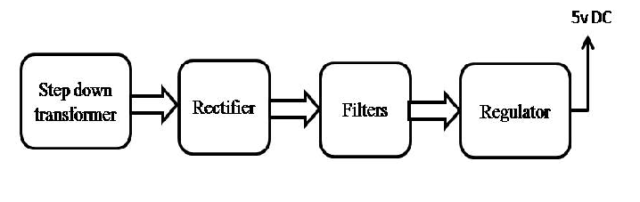Block Diagram:
