Wireless Bluetooth enabled GPS receiver data logger

Global Positioning System (GPS) has been used in various commercial applications including transportation, navigation and vehicle position tracking, which when coupled with Bluetooth wireless technology can help track the complete journey of any vehicle or moving objects like human or animals.

Bluetooth is an open wireless technology standard for exchanging data over short distances (using short wavelength radio transmissions) from fixed and mobile devices, creating personal area networks (PANs) with high levels of security. Bluetooth uses a radio technology with the standard of IEEE 802.15, working at 2.4GHz frequency and bandwidth is 1Mb/s.

This project aims to construct a vehicle position logging system using GPS and wireless Bluetooth technology. The system comprises of following four modules.

- GPS Data Receiver.
- Bluetooth module interfacing.
- RS232 Interfacing.
- Data Processing (PC).

The GPS data receiver module gets the data from GPS receiver and extracts the required data. The system consists of an interface circuit between the Microcontroller and the Bluetooth module. This module transmits the data on to the Bluetooth wirelessly at the interval of two seconds. This data (At the end of the journey) is transferred to PC using RS232 communication. Data capturing is done by the HyperTerminal application on PC.

This data is utilized by PC based application for displaying on a computerized map. This captured data is superimposed on the GoogleEarth map, which covers major cities and towns within India and abroad.

The project works satisfactorily in real time, can locate the vehicle travel locations in the form of longitude, latitude with the margin of error not more than 6 meters from the actual location. This system also logs the information like date, time and speed information of the vehicle.

The major features of this project are:

- Wireless transmission of data using Bluetooth module.
- RS232 based data transmission.
- Mapping the route on the Google map.

This project provides us learning’s on the following advancements:

- SPI protocol implementation.
- GPS Receiver Interfacing.
- Interfacing the Bluetooth module.
- Serial communication with PC.
- RS232 data transmission.
- Embedded C programming.
- PCB design.

The major building blocks of this project are:

- Microcontroller based control system with regulated power supply.
- GPS receiver.
- Bluetooth interfacing system.
- RS232 communication module.
- LED Indicators.
- Control buttons.

Software tools:

1. PIC-C compiler for Embedded C programming.
2. PIC kit 2 programmer for dumping code into Micro controller.
3. Express SCH for Circuit design.
4. Proteus for hardware simulation.
Regulated power supply:

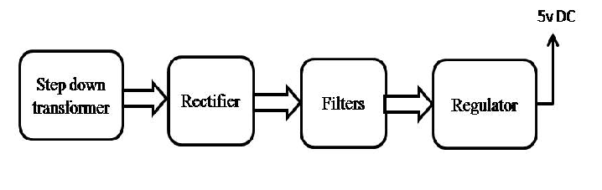

Block Diagram:

