Infrared remote controlled Muscle Stimulator with duration and Intensity Control

The project aims in designing a system which is capable of stimulating the nerves. The described neuron-muscular stimulator stimulates the nerves (neurons) of the part of the body to which the electrodes are attached. It provides relief for headache, muscular pain, or fatigue (due to exertion of muscles) and also revives the frozen muscle which impairs movement. The main function of this electronic instrument is to provide energy to nerve of the muscle and to remove cellulites over. This instrument is interfaced with an IR receiver to control over wireless.

Current stimulator is one of the most commonly used instruments used for diagnosis and treatment of a wide variety of neurological and muscular disorders. It works by forcing electric current into a human system, to elicit information to treat the system.

The muscular stimulator circuit generates 150 µs pulses at 80 Hz frequency, which is then given to the secondary of the transformer to generate 60V positive and 150V negative peaks at very low current so that the patient in not subjected to any shock. The intensity of the current can be varied by changing the resistance which is connected to the pulse generator.

Pulse generator is the heart of the circuit involves a micro controller which generates pulse train. The microcontroller is interfaced with an IR receiver. This IR receiver receives the signal from its corresponding IR remote. The other major advantage of this device is the control of intensity. This feature helps us in setting low intensities to the older people.

Electric muscular stimulation may be unsuitable for subjects with acute pathologies. It should be avoided in the case of osteoporosis or bone tumors, arterial hypertension, pregnancy, cancer, skin pathologies, pacemakers, or arrhythmia (never apply to the heart), kidney deficiency and under treatment of beta blocking drugs.

The main objectives of this project are:

- Stimulating muscles through mild shock.
- Providing intensity control.
- Wireless remote access.

The project provides learning’s on the following:

- Design of IR remote.
- Interfacing IR receiver with the controller.
- Pulse Generation with controller.
- Embedded C program for controller.
- PCB designing.

The major building blocks of this project are:

- Regulated Power Supply.
- Micro Controller.
- IR Receiver
- IR Transmitter.
- LCD display with driver.
- Muscle stimulator unit.
- Crystal oscillator.
- Reset.
- LED Indicators.

Software used:

- PIC-C compiler for Embedded C programming.
- PIC kit 2 programmer for dumping code into Micro controller.
- Express SCH for Circuit design.
- Proteus for hardware simulation.

Regulated Power Supply:

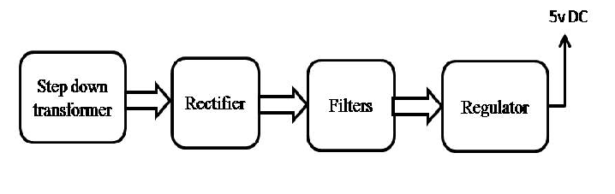

Block Diagram:

