Gas leakage detector & auto dialing controlling system

The project aims in designing a system which is capable of detecting the gas leakage and automatically sends alert messages to predefined numbers. Now a day's every system is automated in order to face new challenges. In present day, Automated systems have less manual operations, flexibility, reliability and accurate. Due to this demand every field prefers automated control systems. Especially in the field of electronics automated systems are giving good performance.

The main aim of this project is to monitor the gas leakage in Industry or Home and if it exceeds, it alerts through the SMS message to mobile phone for the owner and also respective authorities using GSM modem.

The microcontroller gets the information regarding the leakage of any gas through the gas sensor and alerts about the condition being sensed using GSM modem to the mobile phone. By this way we can take the prevention steps before occurrence of the major fire accidents and we can avoid the human losses and financial losses.

The application program for the microcontroller will be written in embedded ‘C’ and will be stored in the flash memory of the microcontroller.

The major features of this project are:

- Provides Home or Industrial security.
- Highly sensitive
- Low cost
- Simple and Reliable.
- User friendly

The project provides learning’s on the following advancements:

- Characteristics of the gas sensor.
- Construction of GSM modem interface.
- Conversion of AC supply to DC supply.
- Embedded C programming.
- PCB design.

The major building blocks of this project are:

- Regulated Power Supply.
- Gas Sensor.
- Micro Controller.
- GSM modem.
- Reset.
- LCD display with driver.
- Crystal oscillator.
- LED indicators.

Software used:

- PIC-C compiler for Embedded C programming.
- PIC kit 2 programmer for dumping code into Micro controller.
- Express SCH for Circuit design.
- Proteus for hardware simulation.

Regulated Power Supply:

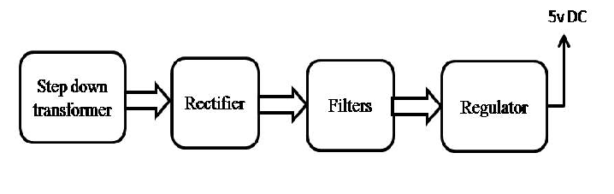

Block Diagram:

