DESIGNING OF PAINTING ROBOT USING SPRAYGUN TOOL

The main aim of the project is to design a robot which is intended for painting purpose. Robot is made up of GEARED DC motors. It will move either in Left or Right and top or bottom directions. These operations of Robot can be controlled by the microcontroller. The predetermined instructions are already loaded in to the Microcontroller by Using Embedded C Programming. All the above processes are controlled by the Microcontroller.

This project makes use of a micro controller, which is programmed, with the help of embedded C instructions. This Microcontroller is capable of communicating with input and output modules. The controller is interfaced with geared DC motors, which are fixed to the Robot to control the direction of the Robot.

This project utilizes two GEARED DC Motors respectively. The GEARED DC motor generates torque directly from DC power supplied to the motor by using internal commutation, stationary permanent magnets, and rotating electrical magnets. It works on the principle of Lorentz force, which states that any current carrying conductor placed within an external magnetic field experiences a torque or force known as Lorentz force.

The driver used for GEARED DC Motors is L293D. The Device is a monolithic integrated high voltage, high current four channel driver designed to accept standard DTL or TTL logic levels and drive inductive loads (such as relays solenoids, GEARED DC and stepping motors) and switching power transistors.

Features of The project

- Ease in understanding the working module.
- Easy to Operate.
- Painting can be done using Robot.
- Can be easily monitored.

The project provides the following learning’s:

- IR technology.
- DC motor working and need for motor driver.
- DC motor interfacing to Microcontroller.
- Embedded C programming.
- PCB designing.

The main building blocks of the project are:

- Regulated Power Supply.
- Microcontroller.
- DC motors with driver.
- IR modules.
- Crystal oscillator.
- Reset.
- LED indicators.

Software used:

- PIC-C compiler for Embedded C programming.
- PIC kit 2 programmer for dumping code into Micro controller.
- Express SCH for Circuit design.
- Proteus for hardware simulation.
Regulated Power Supply:

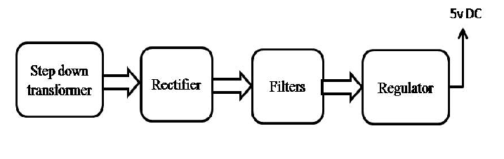

Block Diagram:

