ACCIDENT IDENTIFICATION USING RF TECHNOLOGY

The project aims in designing a system which is capable of detecting the accident and alerting through display and Buzzer alarm system using wireless RF Technology. Now a day’s technology is running with time, it completely occupied the life style of human beings. It is being used everywhere in our daily life to fulfil our requirements. We can not only increase the comfort of life but also increase security with good ideas by making use of advanced technology.

The main aim of this project is to identify any accidents using wireless technology based on RF. When there is an accident occurred to the vehicle, and then the device in the vehicle will transmits the regarding information. The receiver will receive the information and switches an alarm, also shows visual display through LCD display along with the vehicle location. The location will be sent from the RF receiver to the micro controller. RF receivers were placed at the street lights. Whenever the accident occurred then nearest street light will receives the information and sends the information along with street light number.
This Project consists of Microcontroller Unit, LCD display, RF transmitter, RF receiver and a buzzer alarm system.

The action of these instructions is already loaded into the Microcontroller using Embedded C programming. The intelligent control software, which has been developed Embedded C programming language.

The objectives of the project include:

- Alerts when there is any accident occurrence.
- Wireless transmission using RF.
- A buzzer to give alerts.
- LCD to display the status.
- Sending location with help of street light numbers.

The project focuses on the following advancements:

- RF transmission and reception.
- Interfacing RF to the micro controller.
- LCD interfacing.
- Conversion of AC supply to DC supply.
- Embedded C programming.
- PCB designing.

The major building blocks of this project are:

- Regulated Power Supply
- RF Transmitter
- RF Receiver.
- Accident detecting switch.
- Reset.
- LCD display with driver.
- Micro Controller
- LED indicators
- Buzzer with driver.

Software used:

- PIC-C compiler for Embedded C programming.
- PIC kit 2 programmer for dumping code into Micro controller.
- Express SCH for Circuit design.
- Proteus for hardware simulation.

Regulated Power Supply:

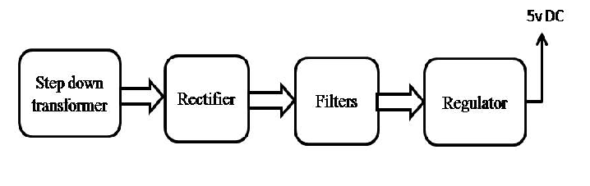

Block diagram:

