Zigbee based Wireless Electronic Notice Board with
Multi Point Receivers

The aim of the project is to design a wireless electronic notice board using Zigbee technology. Notice Board is primary thing in any institution / organization or public utility places like bus stations, railway stations and parks. But sticking various notices day-to-day is a difficult process. A separate person is required to take care of this notices display. This project deals about an advanced hi-tech wireless notice board.

Zigbee is a WPAN technology based on the IEEE 802.15.4 standard. Unlike Bluetooth or wireless USB devices, ZigBee devices have the ability to form a mesh network between nodes. Meshing is a type of daisy chaining from one device to another. This technique allows the short range of an individual node to be expanded and multiplied, covering a much larger area.

PC is interfaced to the transmitter to type the data and transmit. The message can be transmitted to multi point receivers. At any time the user can add or remove or alter the text according to his requirement.

This system has microcontrollers to which Zigbee modules are interfaced. The notices can be written on PC and transmitted through Zigbee. The receivers at the notice board receives this information and feds this information to the microcontroller which processes this information and displays it on a LCD.

Features:

- Low power consumption.
- Highly sensitive.
- Implementation of multi point receiver.
- Implementation of REAL TIME embedded system, which involves hardware and software interaction.

This project provides exposure to the following technologies:

- Zigbee technology.
- Interfacing Zigbee modules to Microcontroller and PC.
- Embedded C programming.
- Design of PCB.
- LCD interfacing.
- Wireless Data Transmission over Zigbee protocol.

The major building blocks of this project are:

- Regulated power supply.
- Zigbee modules.
- LCD with driver.
- Crystal oscillator.
- LED indicators.
- Microcontroller.

Software used:

- PIC-C compiler for Embedded C programming.
- PIC kit 2 programmer for dumping code into Micro controller.
- Express SCH for Circuit design.
- Proteus for hardware simulation.

Regulated Power Supply:
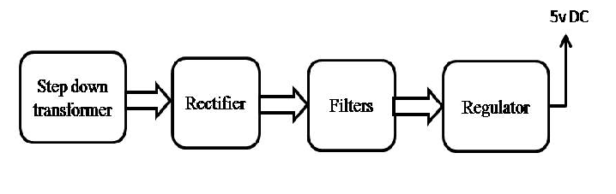

Block diagram:
System at place where notices are updated:
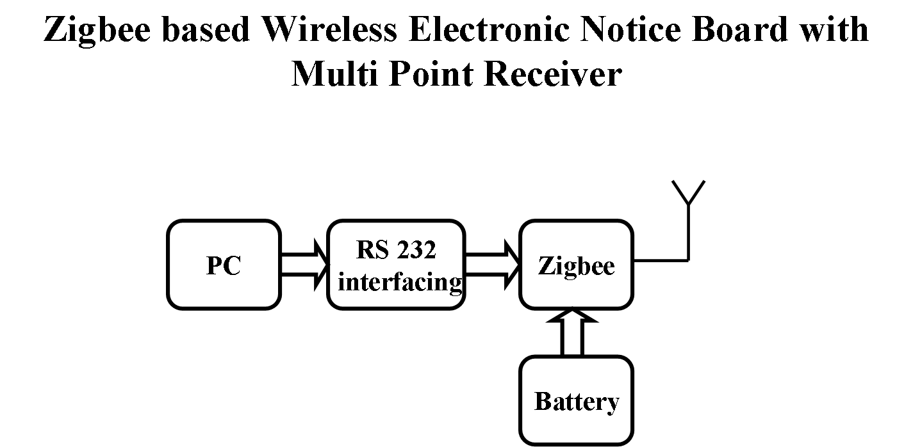

Receiver 1:
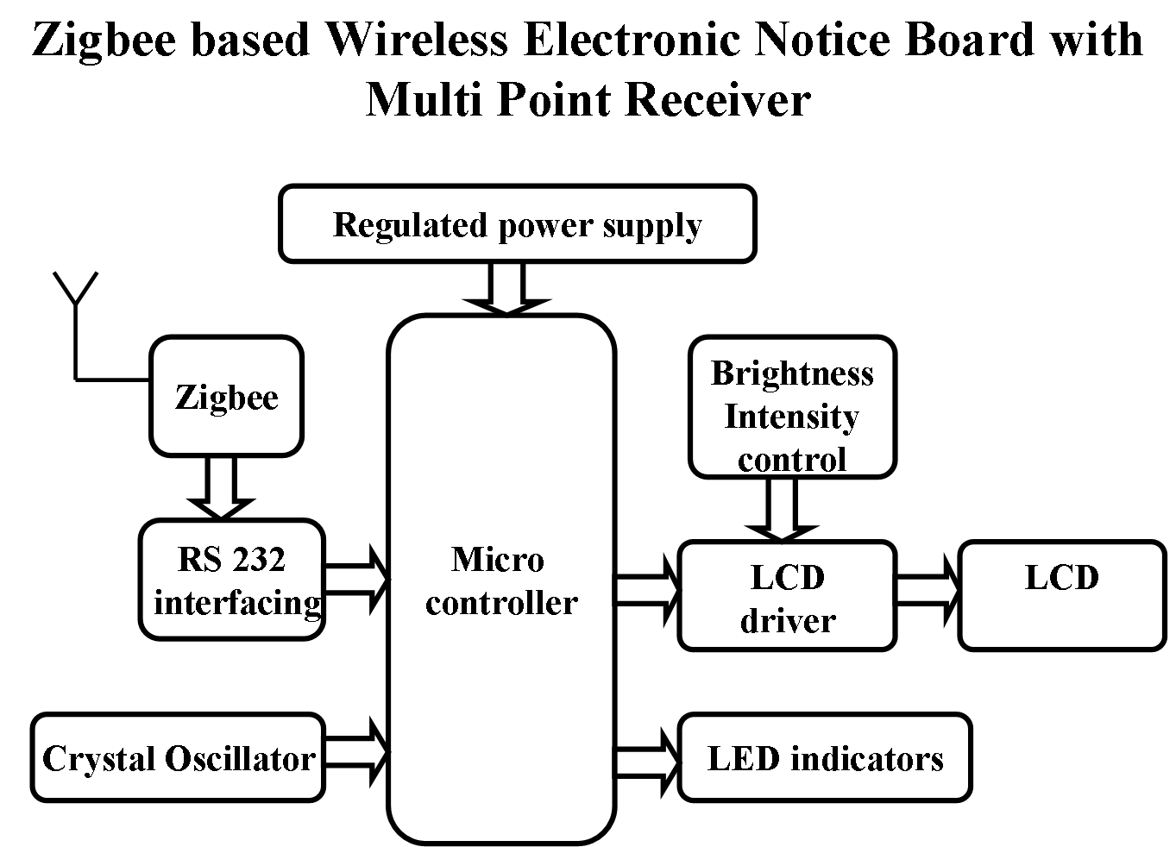
Receiver 2:

