RFID based digital library system and alerts

The project aims in designing a digital library system which is capable of keeping track on the library resources and alerts if any library resource is taken unauthorized. An Operating a library involves in keeping track large number of resources such as books and magazines. Radio Frequency Identification (RFID) technology has been promoted in recent years as an alternative technology in improving asset management in a library. The RFID tags were applied to replace bar code and magnetic stripe functions as identification and anti-theft detection.

In this project the RFID tags are attached to each and every library book and the two RFID readers are placed, one near the librarian and another at the exit of the library. When any person enter with the library book the RFID reader near the librarian decodes the RFID tag which is attached to the library book and the librarian updates the data of that particular book and sends book registration details into the system and presses the permit button in the system. The details of the book are displayed on LCD display unit.

The another RFID reader which is at the exit will continuously monitor RFID tag of each and every library book and checks that the book is registered or not, if it found any unregistered book then the Microcontroller will switch on the Alarm using buzzer. This system alerts the librarian when any book is found unregistered.

Microcontroller is also termed as an onboard computer. This onboard computer has many input and output ports through which it communicates with other peripheral devices. The microcontroller is embedded with an assembly language called hex file which consists of a sequence or set of instructions to control different other modules in the project.

The main objectives of the project are:

- Alerts whenever library resources are taken out without registration.
- Keeps track of all the library resources.

The project provides us exposure on:

- Initialization of microcontroller.
- Embedded C program.
- PCB designing.
- Conversion of AC supply to DC supply.
- Two RFID modules.
- LCD display unit.

The Major Building blocks of this project are:

- Regulated Power Supply.
- Microcontroller.
- RFID reader and tag.
- LED Indicators.
- Crystal Oscillator.
- Reset.
- Control buttons.
- Buzzer.
- LCD display with driver.
Software used:

- PIC-C compiler for Embedded C programming.
- PIC kit 2 programmer for dumping code into Micro controller.
- Express SCH for Circuit design.
- Proteus for hardware simulation.

Regulated Power Supply:

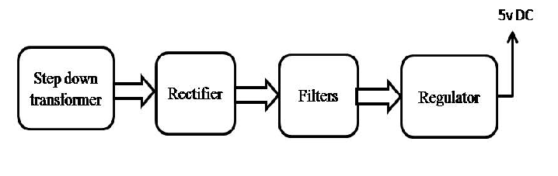
Block Diagram:

