Electronic Passport using RFID

The project aims in designing a system which helps in getting passport registration details instantaneously using RFID technology. This is very much helpful for the officers to extract the details of the registered person instantaneously and also to identify non registered persons.

Automation is the most frequently spelled term in the field of electronics. The hunger for automation brought many revolutions in the existing technologies. One among the technologies which had greater developments is RF communications. The result of this is the RFID cards which transmit a unique identification number. This number transmitted by the RFID can be read with the help of a RF reader.

The main aim of this project is to extract passport registration details based on RFID technology. In this project the RFID tags are given to the registered person instead of passport, and the RFID reader which is interfaced to microcontroller decodes the RFID tag of the particular passport and that particular passport registration details are displayed on LCD and also the information is sent to the PC of the registration office through RS232 cable.

Micro controller forms the controlling module and it is the heart of the device. The controller performs the functionality of receiving data from the RFID. The microcontroller is programmed in such a way that the data from microcontroller is continuously sent to PC. When any passport passes through the security system then the RFID reader reads the tag of the passport and the received data will be fed to PC through a Microcontroller. When any passport is recognized as unauthorized then the system alerts through buzzer alarm. The Microcontroller is programmed using Embedded C language which provides effective environment in performing the task.

The major features of this project are:
- Data logging into PC.
- Identification of passports through RFID communication.
- Automatic display of passport details on LCD.
- Alerting through buzzer alarm system when the passport is detected.

This project provides us learning’s on the following advancements:

- RS232 protocol implementation.
- RFID technology.
- Serial communication with PC.
- Embedded C programming.
- PCB design.

The major building blocks of this project are:

- Regulated Power Supply.
- RFID reader and tag.
- LCD display with driver.
- Buzzer with driver.
- Micro controllers.
- Crystal oscillator.
- Reset button.
- RS232 cable.
- MAX-232.
- Crystal oscillator.
- LED indicators.

Software’s used:

1. PIC-C compiler for Embedded C programming.
2. PIC kit 2 programmer for dumping code into Micro controller.
3. Express SCH for Circuit design.
4. Proteus for hardware simulation.

Regulated Power Supply:

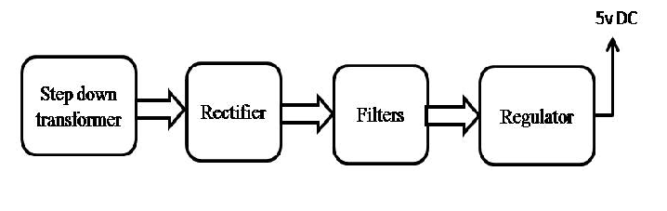
Block diagram:

