DC Motors speed synchronization for rolling mills

The project aims at designing a system which is capable of synchronizing the speed of the slave motor (motor-2) with the master motor (motor-1). This system finds very useful in paper mills, steel industries etc..,. The master motor speed can be set manually through the potentiometer available in the system.

Industrial environment in day-to-day life demands for a synchronization between multiple devices present in the industry. One among such application is the synchronization between multiple devices available in the industries. So there should be a common synchronization between all these motors. Among the available motors even of single motors RPS is more the loss may be more. So keeping all these factors into consideration we designed a system, which is capable of driving multiple DC motors with the same speed, or RPS without any approximation.

The final aim of the project is achieved by making use of a controller based mother board which uses a uniquely designed power supply, two DC motors, Speed sensing sensor, LCD display. One of the motor acts as a follower while the other motor n speed can be set manually.

The controller unit forms the intellectual part of the device. It makes use of a non-contact sensor to sense the speed of the DC motors. The speed synchronization is provided with the help of the PMW technique. An LCD is provided with the controller for displaying the information for user interface. The controller is also provided with a potentiometer to set the speed of master motor.

The main features of this project are:

- Real time DC motor speed setting.
- Display of DC motor speed on LCD.
- Contact less speed monitoring.
- Dynamic speed setting feature.
- PWM based speed adjustment.

The project provides the following learning’s:

- DC motor principles of operation.
- PWM technique for synchronization.
- Micro controller interfacing with DC motor.
- Embedded C programming.
- PCB Designing technique.

The major building blocks of this project are:

- Regulated Power Supply.
- Microcontroller.
- Speed sensor.
- Potentiometer.
- Liquid crystal display with driver.
- DC motors with driver.
- Crystal oscillator.
- LED indicators.

Software used:

- PIC-C compiler for Embedded C programming.
- PIC kit 2 programmer for dumping code into Micro controller.
- Express SCH for Circuit design.
- Proteus for hardware simulation.

Regulated Power Supply:

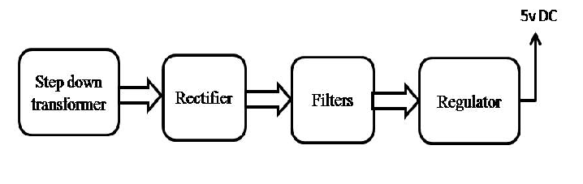
Block Diagram:

