DC motor speed and direction controller using DTMF mobile phone

The purpose of this project is to control the speed and direction of DC Motor using DTMF technology. In this project speed of the motor can be controlled by using an additional feature of PWM (Pulse Width Modulation) technique from 0% to 100%.

The speed of the motor is measured using contact-less speed measurement. Here we are going to operate the DC motor speed and direction. For this we will use DTMF (Dual Tone Multiple Frequency) technology. To operate the motor we should make a call to the mobile phone which is placed at the control unit. That mobile phone will be automatically answered after one or two rings then the control of the motor is in our hands by using keypad buttons of our mobile phone the motor speeds will changes. And we can also change the direction of the motor by pressing the appropriate key buttons.

Microcontroller plays a major role in our project, which it is capable of controlling the whole external devices. DTMF decoder is interfacing to controller unit.

Features of this project:
- Remote monitoring and controlling of DC motor.
- Can be operated from anywhere in the world.
- Reliable for industrial and domestic needs.
- Automatic remote speed measurement.

The project focuses on the following areas:
- DTMF decoder.
- DTMF and microcontroller interface.
- Embedded C programming.

The major building blocks of this project are:
- Microcontroller based control system with regulated power supply.
- DC Motor.
- DC Motor Driver L293D.
- DTMF decoder.
- PWM for Speed Control of Motor

Regulated power supply:

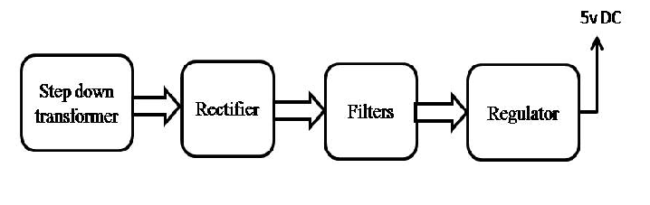

Block Diagram:

