3 G Mobile phone controlled landmine location
identification robot

“3 G Mobile phone controlled landmine location identification robot” is an automatic monitoring system and controlling the robot by using DTMF technology, as it is a wireless Robot it can be easily mobilized and also controlled. The system is also used to detect human beings using PIR sensor, metal detection and fire alerts will be send as SMS to the predefined phone number using GSM modem along with the location co-ordinates. And the video images thus recorded can be seen live on 3 G mobile phone. It is a very low cost survey line system used for detecting human beings and bomb identified locations.

In this project we use micro controller, which is programmed to control the input and output modules interfaced to it. The controller makes use drivers; depending upon the indications the DC motors can be rotated. With the help of mobile keypads operations will be done. Also to detect bomb we are going to make use of metal detecting sensor, for fire detection and temperature monitoring purpose we are going to use fire sensor. To get the location based monitoring the robot consists of GPS.

This project is used to detect the human being by using the wireless remote controlled Robot, which have the sensors that detects the presence of the human being and indicates the user. As it is a wireless Robot it can be easily mobilized and can be controlled. This can be used to detect terrorists/thief inside the building. When any person comes near the robot the PIR sensor which is with the robot detects the human being and alerts through buzzer and also sends video images on 3 G mobile phone.

Also a mobile phone which will operate the robot directions and speed based on the DTMF technology. DTMF (Dual Tone Multiple Frequency) depends upon the keypad tones where as each tone can generate certain frequency depending on that, the robot will operate and it will increase or decrease the speed.

The main objectives of this project are:
- Design of real time robot.
- Real time human detection.
- Wireless control of robot directions and movement.
- Monitors video in industrial environment.
- Wireless video transmission over 3G mobile phone
- Location based status monitoring of bombs.
- Getting SMS alerts when metal or live human being identified.

The learning’s provided by the project are:
- DTMF technology.
- Interfacing DTMF decoder with controller.
- Interfacing GPS with controller.
- Interfacing GSM with controller.
- DC motors controlling through controller.
- Characteristics of PIR sensor.
- Characteristics of Metal sensor.
- Interfacing PIR with controller.
- Embedded C programming with controller.
- PCB design concepts.

The major building blocks of this project are:
- Micro controller Mother Boards with regulated power supply.
- GPS Module.
- DTMF decoder.
- GSM modem.
- PIR Module.
- Fire sensor.
- Metal sensor.
- Robot Vehicle with two DC Motors.
- 3 G video transmission.
- LED Indicators.

Software’s used:
  - PIC-C compiler for Embedded C programming.
  - PIC kit 2 programmer for dumping code into Microcontroller.

Regulated power supply:

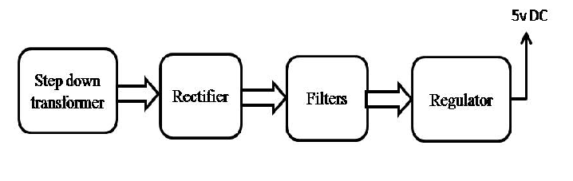

Block diagram:
