Military Persons Training System using GPS and GPRS based real time tracking on Google Earth

The project aims in designing a system which is capable of continous monitoring of path of the vehicle on PC with Google Earth Application and also capable of logging the vehicle traveled path into a MMC/SD card and later plots this in Google Earth application on PC. Global Positioning System (GPS) has been used in various commercial applications including transportation, navigation and vehicle or human position tracking, which when coupled with external memory stick the technology can help track the complete journey of any vehicle or military persons.
This project consists of GPS receiver present in the vehicle system which continuously gets location information from the satellites and GPRS modem; placed in vehicle system,. The GPRS modem, which is present in the vehicle, will continuously send location information into a web-link.
GPS is the acronym for Global Positioning System. It is employed to find the position, velocity, time of anything located on the earth. This information is provided by the GPS receiver with the help of the data it receives from the satellites.
This project aims to construct a vehicle position logging system using GPS and SD/MMC (Secure Digital/Multi Media Card). The system comprises of following four modules.
- GPS Data Receiver.
- SD/MMC memory card interfacing.
- RS232 Interfacing.
- Data Processing (Microcontroller).
The GPS data receiver module gets the data from GPS receiver and extracts the required data. The data storage module consists of an interface circuit between the Microcontroller and the SD/MMC card. This module transmits the data on to the SD/MMC card at the interval of two seconds. This data (At the end of the journey) is transferred to PC using RS232 communication. Data capturing is done by the HyperTerminal application on PC.

This data is utilized by PC based application for displaying on a computerized map. This captured data is superimposed on the Google Earth map, which covers major cities and towns within India and abroad.
The project works satisfactorily in real time, can locate the vehicle travel locations in the form of longitude, latitude with the margin of error not more than 6 meters from the actual location. This system also logs the information like date, time and speed information of the vehicle.
Micro controller forms the controlling module and it is the heart of the device. The controller performs the functionality of receiving data from the GPS. The microcontroller is programmed in such a way that the data from GPS receiver is processed and continuously sent through GPRS modem. The data is uploaded to a pre-defined web-link through a GPRS modem interfaced to the Microcontroller. The received data is tracked on the Google Earth application in the PC. A line driver MAX232 is used to convert CMOS levels to RS232 levels. The Microcontroller is programmed using Embedded C language which provides effective environment in performing the task.

The major features of this project are:

- Data logging into PC.
- Wireless data transmission.
- Mapping the route on the Google map.
- Usage of GPRS modem.
- 2GB Memory available for storing the data.
- RS232 based data transmission.
- Mapping the route on the Google map.
- Store data of one year travel time.
- Microcontroller can format memory Card.

This project provides us learning’s on the following advancements:
- RS232 protocol implementation.
- Interfacing the MMC/SD card.
- Serial communication with PC.
- RS232 data transmission.
- GPRS technology.
- GPS technology.
- Embedded C programming.
- PCB design.

The major building blocks of this project are:

- Regulated Power Supply.
- Global Positioning System (GPS Receiver).
- GPRS modem.
- LCD display with driver.
- Micro controller
- Crystal oscillator.
- Reset button.
- MAX-232.
- Memory Stick (MMC) with driver.
- LED indicators.

Software’s used:

- PIC-C compiler for Embedded C programming.
- PIC kit 2 programmer for dumping code into Micro controller.
- Express SCH for Circuit design.
- Proteus for hardware simulation.

Regulated Power Supply:

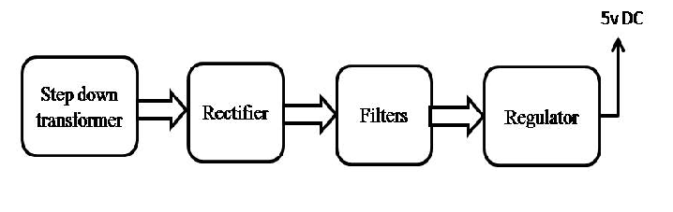
Block diagram:

