MEMS Accelerometer based Self balancing Platform
The aim of this project is to build a Platform Vehicle that can be controlled by using wireless MEMS (Micro Electro-Mechanical Systems) based accelerometer. MEMS is a Micro electro mechanical sensor which is a high sensitive sensor and capable of detecting the tilt. This sensor finds the tilt and makes use of the accelerometer to increase or decrease the tilt of the platform depending on the tilt. This kind of tilt detection platform can be helpful for the civil engineers in the construction works it helps to detect the slopes in the beamers, floors etc. which can be easily done with out any manual interference.
This project makes use of an on board computer which is programmed with the help of embedded C instructions. This on board computer is capable of communicating with both the input and output modules. The MEMS based sensor detects the tilt and provides the information to the microcontroller (on board computer) and the controller judges whether it is a positive or negative slope. Depending on the slope the acceleration of the platform is controlled which is done dynamically by the controller.
This project provides us with the learning’s on the fallowing aspects:

- Characteristics of MEMS
- Interfacing Motors with Microcontroller.
- Interfacing MEMS with Microcontroller.
- Embedded C programming.
- PCB interfacing.
The major building blocks of this project are:
- Microcontroller Mother Boards with regulated power supply.
- MEMS based sensor.
- Platform with one PWM controlled DC Motor.
- High power Motor Drivers.
- LED indicator.
Regulated power supply:
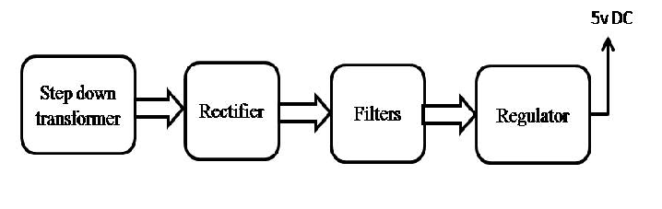
Block diagram:

