Location aware mobile phone signal strength logger into 2 GB memory card

The project aims in designing a system which is used to identify the network signal strength of a mobile phone and also capable of logging data into a MMC card using GSM and GPS modules.
The GPS is the acronym for Global positioning system. This GPS receiver is capable of identifying the location in which it was present in the form of latitude and longitudes. It is employed to find the position where the user is located on the earth. The GPS gives the data received from the satellites. For this information the GPS communicates with at least three satellites in the space.
The GSM modem provides the communication mechanism between the user and the microcontroller system by means of SMS messages. It is capable of receiving a set of command instructions in the form of Short message service and performs the necessary actions. We will be using a dedicated modem/mobile at the receiver module i.e and send the commands using SMS service as per the required actions.

We make use of both these devices to get the mobile phone signal strength based on location given by the GPS receiver. The controlling device of the whole system is a Microcontroller and GSM modem, GPS receiver, MMC card are interfaced to it. The Microcontroller is programmed in such a way that the mobile phone’s exact location is fed as input to controller using GPS receiver and also the network signal strength of that mobile phone using GSM modem. The microcontroller processes this data and logs the data into MMC card. Whenever user requests the data by sending an SMS in pre-defined format to the number in the GSM modem, the controller validates it and sends the data regarding signal strength information at that current moment by SMS through GMS modem interfaced to it. The microcontroller is programmed using Embedded C language which provides an effective environment in performing the task.

The main objectives of the project are:
- Real time monitoring of the network signal strength.
- Remote storage of data.
- Large storage space.

The project provides the following learning’s:
- Microcontroller interfacing with GSM modem.
- Microcontroller interfacing with GPS receiver.
- GSM and GPS technologies.
- 2 GB MMC card interfacing with microcontroller.
- Serial communication protocols.
- Conversion of AC supply to DC supply.

The main building blocks of the project are:
- Regulated Power Supply.
- Microcontroller.
- GSM modem.
- GPS receiver.
- 2 GB MMC/SD memory card.
- Crystal oscillator.
- LCD display unit.
- LED indicators.

Software’s used:

1. PIC-C compiler for Embedded C programming.
2. PIC kit 2 programmer for dumping code into Micro controller.
3. Express SCH for Circuit design.
4. Proteus for hardware simulation.
Regulated Power Supply:

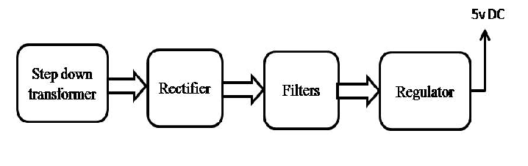

Block diagram:

