Intelligent train security system

The project aims in designing a system which alerts the railway authorities when any fire accidents occurs in the train and this system also provides an immediate effect which controls fire using controlling system. The project mainly helps to avoid accidents which usually occurs when crack occurs on track using Rf technology

This system has two main sections:
- in the train
- at the railway station

If temperature exceed the set value immediately it send information to station display on pc, As well as it send to driver display on LCD.And also if any crack detecting knows by some one immediately station manager send crack detection information to the driver through Rf technology
The module in the train has a temperature sensor which continuously monitors the temperature. The temperature is read by the ADC (Analog to Digital Converter) module of the microcontroller Unit. This ADC data is processed and converted into the actual temperature reading by the microcontroller in the train. If the temperature exceeds threshold level (Fire accidents) then the Zigbee module in the train transmits this information as an alert to the railway station authorities. Also, starts the fire extinguishing system automatically. The Microcontroller which is the controlling device of the whole system is programmed using Embedded C language.

Zigbee is a WPAN technology based on the IEEE 802.15.4 standard. Unlike Bluetooth or wireless USB devices, ZigBee devices have the ability to form a mesh network between nodes. Meshing is a type of daisy chaining from one device to another. This technique allows the short range of an individual node to be expanded and multiplied, covering much larger area.

PC is interfaced to Zigbee module at station to display an alert message whenever fire accident occurs in the train. The message can be transmitted to multi point receivers.

Features:

- Low power consumption.
- Fire sensing.
- Auto fire fighting (fire Extinguishers).
- Highly sensitive.
- Implementation of real time embedded system, which involves hardware and software interaction.

This project provides exposure to the following technologies:

- Zigbee technology.
- Embedded C programming for microcontroller.
- Interfacing of Temperature sensor.
- Design of PCB.
- LCD interfacing.
- Wireless Data Transmission over Zigbee protocol.

The major building blocks of this project are:

- Regulated power supply.
- Zigbee modules.
- Temperature sensor.
- Relay with driver.
- Rf tx module
- Rf rx module
- Control buttons.
- DC motors with driver
- Microcontroller.
- Crystal oscillator.
- LED indicators.
- MAX232 based serial interfacing.
- Reset.
- buzzer
- water tank

Software used:

- PIC-C compiler for Embedded C programming.
- PIC kit 2 programmer for dumping code into Micro controller.
- Express SCH for Circuit design.
- Proteus for hardware simulation.

Regulated Power Supply:

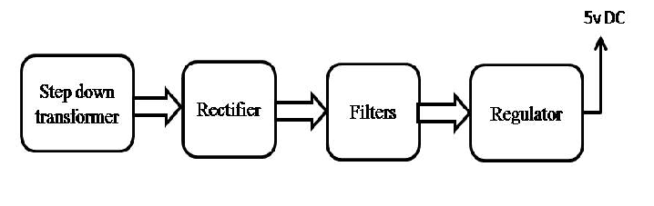

Block diagram:
This system has three main sections:
- at the signal point
- in the train
- at the railway station

