IOT AND MEMS GESTURES BASED DEVICE SWITCHING

The main aim of this project is to design and construct a gestures movement controlled device switching system for physically challenged. The user can wear MEMS accelerometer on any body part and through gestures they can control powered devices like fan, light, etc.., The status of devices can be seen in IOT webpage.

For IoT communication, we are making use of 32bit esp8266 controller along with PIC microcontroller for sensors interface. Accelerometer is an electromechanical device that measures acceleration forces. These forces may be static, like the constant force of gravity pulling at our feet, or they could be dynamic - caused by moving or vibrating the accelerometer. MEMS accelerometers are one of the simplest but also most applicable micro-electromechanical systems. They became indispensable in automobile industry, computer and audio-video technology.

This project makes use of a Relay and Triac for switching the devices. The Microcontroller decides which device to be operated from the input it gets through the body gestures. The Microcontroller is loaded with an intelligent program written using embedded ‘C’ language.

The main objectives of the project are:

- Simple gestures movement based operation.
- Gestures movement based device switching.

This project provides us with the learning’s on the following aspects:

- Characteristics of MEMS accelerometer sensor
- Interfacing of MEMS accelerometer with Microcontroller.
- Appliances interfacing with the controller.
- Embedded C programming.
- PCB Design concepts.

The major building blocks of this project are:
- Regulated power supply.
- Microcontrollers.
- Crystal Oscillator.
- MEMS accelerometer.
- Electromagnetic Relay with driver.
- Triac with driver
- Reset.
- LED indicators.

Software used:

- PIC-C compiler for Embedded C programming.
- PIC kit 2 programmer for dumping code into Micro controller.
- Express SCH for Circuit design.
- Proteus for hardware simulation.

Regulated Power Supply:

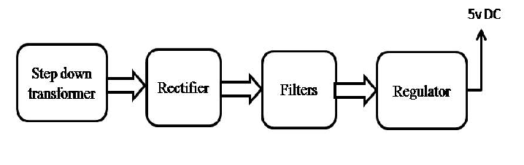
Block diagram:

