Vehicles Count and Speed Display System for High ways and High Speed alerts with Vehicle number using RFID and GSM

This project aims in providing a user friendly, reliable system to count the number of vehicles and speed of vehicle using ultrasonic modules and display on the LCD (Liquid Crystal Display). The vehicle number can also be known by using RFID technology. When any vehicle moves with high speed, this system alerts by displaying the speed of vehicle with vehicle number on LCD using RFID technology and also sends the information in the form of SMS messages through GSM modem available in the system to the traffic police station.
The ultrasonic sensors are mounted on the highway. When a vehicle passes, the ultrasonic sensors senses the speed .This will be fed to the microcontroller which counts the number of vehicles as well as speed of the vehicles and displays on LCD. RFID tag is with the vehicle and whenever the vehicle passes the RFID reader decodes the RFID tag and the vehicle number is displayed on the LCD. This application is very useful for traffic controlling departments to monitor the speed of the vehicles and also can get the high speed alerts with vehicle number using RFID technology and this information can be sent to traffic police station through SMS.
The controlling device of the whole system is a Microcontroller. IR sensor module, RFID reader acts as input modules to the Microcontroller, where as LCD display and GSM modem acts as output. Whenever a vehicle speed goes beyond a set threshold level the controller reads the RFID tag of that vehicle through RFID reader and displays it on the LCD and also sends SMS. Also, vehicle count is also displayed on the LCD. The Microcontroller is programmed using Embedded C language.

The main objectives of the project are:
- Vehicle speed and count display on LCD.
- Also, vehicle number display.
- Alerts about over speed vehicles through LCD.
- Over speed information along with vehicle number to traffic police station in the form of SMS.
This project provides exposure to the following technologies:
- IR sensor technology.
- Interfacing Ultrasonic sensor to the controller.
- RFID reader and Tag
- Interfacing RFID reader with microcontroller.
- Embedded C programming.
- PCB designing.

The main building blocks of the project are:
- Regulated Power Supply.
- Microcontroller.
- IR sensor modules.
- GSM modem.
- RFID reader with tag.
- LCD display with driver.
- Crystal oscillator.
- Reset.
- LED indicators.

Software’s used:

- PIC-C compiler for Embedded C programming.
- PIC kit 2 programmer for dumping code into Micro controller.
- Express SCH for Circuit design.
- Proteus for hardware simulation.

Regulated Power Supply:

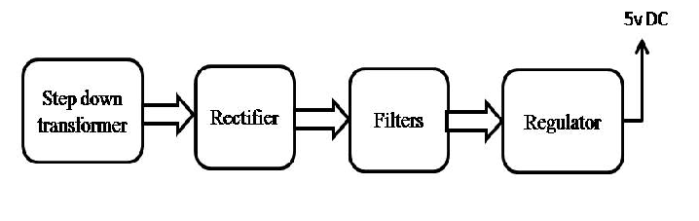
Block Diagram:

