GPS and GSM based office cab monitoring, alerting and logging System.

GPS and GSM based office cab monitoring, alerting, logging system aims in monitoring the travel path of the office cab and alert the passenger whenever the path is deviated. This also provides with immediate alerts to the remotely located security departments in the form of SMS messages. This device finds its extreme applications in the corporate environment where the employees leave or come to their duties late nights in their office cabs.

Data logging is the mechanism of storing data received from a transmitting module. We usually go for data logging whenever we are communicating with a high-speed device. The main purpose of data logging is to avoid the loss of data. In our project data logging is done from the GPS to the SD Memory card.

The device is designed such that the GPS send the data related to the location in which it was present a control unit, the control unit writes this data into the memory card. The data written into the memory card can be transmitted to the Personal computer through SD card reader.

GPS is the acronym for Global Positioning System. It is employed to find the position where the user is located on the earth. This information is provided by the GPS with the help of the data it receives from the satellites.

Arduino Microcontroller forms the controlling module and it is the heart of the device. The controller performs the functionality of receiving data from the GPS. The controller can be operated in two modes depending on the user input. In order to interact with the user the controller is provided with few control buttons. The controller takes the input from the user and depending on that it either operates in write mode or read mode. In write mode it writes the data into the SD card, while in the read mode it reads the data from the memory card. It also makes use of one more control button to format the data in the memory card.

The major features of this project are:
- SD Memory available for storing the data.
- Wireless data transmission.
- Mapping the route on the Google map.
- Alerting the people inside the cab about the wrong direction.
- Automatic message alerts to the remotely present security department.

This project provides us learning’s on the fallowing advancements:
- AT commands for communication with GSM modem.
- Accessing the SD memory card.
- Embedded C programming.
- PCB design.

The major building blocks of this project are:
- Regulated Power Supply.
- Global Positioning System (GPS Receiver).
- GSM modem.
- SD Memory Card Interfacing Circuitry.
- Arduino Microcontroller.
- LCD Display

Software’s used:

1. Arduino compiler for Embedded C programming.
2. Arduino programmer for dumping code into Micro controller.
3. Express SCH for Circuit design.

Regulated power supply:

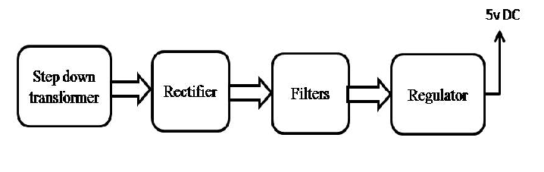

Block diagram:

