FABRICATION OF SOLAR IRRIGATION SYSTEM
The project aims in designing a system which is capable of detecting moisture level in the soil and capable of taking the decision of switching ON/ OFF water pump. The system also uses temperature sensor to detect the temperature level and control the water pump automatically using TRIAC switch.

The system makes use of a comparator. The output from soil moisture detecting probes sensor is fed to comparator. The comparator will continuously compare output from probes and reference voltage and generates logic low or high. The output generated from comparator is used to drive a water pump through a TRIAC switch. The system also alerts through buzzer alarm when the soil moisture sensor detects water and also when the temperature rises high.

The major features of this project are:

- Automatic switching of Water pump.
- Simple electronic circuit.
- Automatic temperature and moisture detection using sensors.
- Automatic alerting using buzzer alarm.

The project provides learning’s on the following advancements:

- Designing of soil moisture and temperature sensors.
- Conversion of AC supply to DC supply.
- Comparator working principle.
- TRIAC working principle and need for driver.
- PCB design.
The major building blocks of this project are:

- Regulated Power Supply.
- Comparator.
- Soil moisture sensor.
- TRIAC with driver.
- Reference voltage (Potentiometer).
- Temperature sensor
- Buzzer.

Regulated Power Supply:

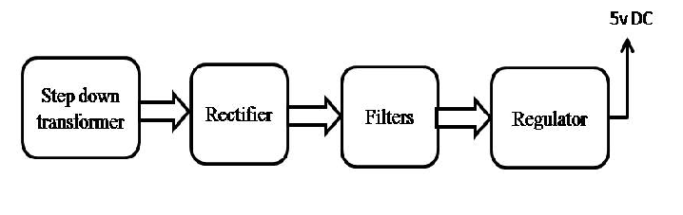

Block Diagram:

