EyeBlink controlled Intelligent Wheel chair

The aim of this project is used to control a wheel chair by using Eye Blink technology. Eye Blink Sensor which is a highly sensitive sensor and capable of detecting the Eye Blink of a human This sensor detects the Eye Blink and makes use to change the direction of the wheel chair depending on Number of Eye Blinks. For example if the Blink Rate is 4 then the entire system gets unlocked, when it is one blink the wheel chair moves in forward direction, when two blinks were detected the wheel chair moves backward, when it moves right the blink count must be 3, and for 4 count it moves left direction.

Automation is the most frequently spelled term in the field of electronics. The hunger for automation brought many revolutions in the existing technologies. One among the technologies, which had greater developments, is the Eye Blink sensor. These had greater importance than any other technologies due its user-friendly nature. Eye Blink based devices can be easily reachable to the common man due to its simpler operation, and at the same time it challenges the designers of the device.
This device is portable and this system operation is entirely driven by Micro controller. User can wear as spectacles and operate the wheel chair by Eye Blinks Using Eye Blink Sensor.

This project makes use of a micro controller, which is programmed, with the help of embedded C instructions. The EyeBlink sensor detects the Blink Rate and provides the information to the PIC microcontroller (on board computer) and the controller judges whether the instruction is right movement or left movement instruction and controls the direction respectively. The controller is interfaced with two dc motors to control the direction of the wheel chair.

Features:
- Can be easily monitored.
- Ease in understanding the working module.
- Easy to operate.
- Low power consumption.

This project provides us with the learning’s on the following aspects:
- Characteristics of EyeBlink Sensor
- Interfacing Motors with PIC microcontroller.
- Interfacing EyeBlink with PIC microcontroller.
- Embedded C programming.
- PCB Design and development.
The major building blocks of this project are:
- PIC microcontroller Mother Board with regulated power supply.
- EyeBlink sensor.
- Wheel chair with DC Motors
- LED indicators
Software’s used:

- PIC C Compiler software for embedded C programming.
- PIC kit-2 programmer for dumping code into Microcontroller.
- Express SCH for Circuit design.
- Proteus for hardware simulation.
Regulated power supply:
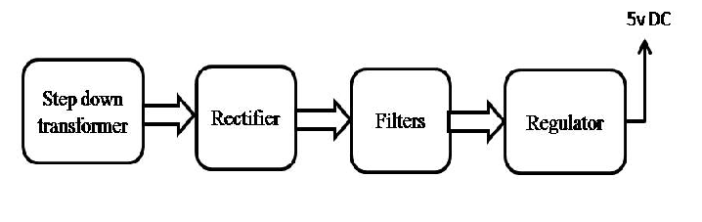
BLOCK DIAGRAM:

