Design and construction of Earth Fault relay for single-phase system
Earth fault or leakage of current is a very common problem in electrical circuits. This leads to unnecessary power loss. The purpose of this project is to develop a system that senses the earth fault in single-phasing system and alerts the user about it. The similar sensing mechanism also can be employed in 3-phase system.
This consists of two electrically isolated current sensors for sensing the amount of current flowing through the circuit. One of the current sensors is connected to phase line of the supply and the other is connected to neutral line. A microcontroller based control system continuously monitors the amount of current passing through both phase and neutral lines of the power supply circuit. In ideal conditions the amount of current passing through the phase and neutral should be same. In case of earth fault, the amount of current entering into the circuit will not be equal to the current leaving the circuit. In such situations the microcontroller-based system alerts the user about this in the form of text and audible alerts. This system also displays amount of current leakage into the earth.

Features:
- Instantaneous earth fault identification.
- Automatic circuit breaker operation.
- Visual status display.
- Variable trigger point for leakage current.

Applications:
- Domestic earth fault monitoring.
- Single phase industrial protection.
- Avoids power loss.
- Avoids unnecessary tariff.

The project provides exposure on:
- Initialization of ADC module of microcontroller.
- Current sensors interfacing to microcontroller.
- Relay interfacing.
- Embedded C program.
- PCB designing.
- LCD interfacing.
The major building blocks of this project are:
- Microcontroller based control system with regulated power supply.
- Two electrically isolated current sensors.
- Electromagnetic relay.
- Buzzer.
- LED Indicators.
- LCD display.
Regulated power supply:
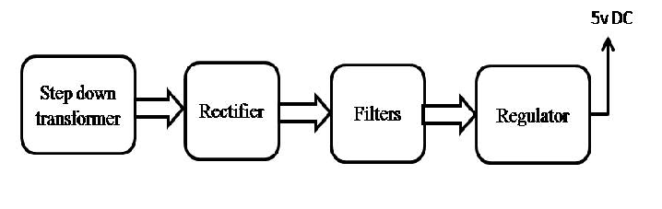

Block Diagram:
