DTMF controlled bomb detecting robot

The aim of this project is to design automatic robot for detecting bombs and also which is capable of receiving a set of command instructions in the form of DTMF tones and performs the necessary actions like moving to left or right directions. Here DTMF stands for “Dual tone multiple frequency”.

This project describes a new economical solution of robot control systems by employing a DTMF mobile, a microcontroller, few DC motors for direction control, and an interfacing between the different modules of the project and the controller. The robot directions are can be controlled by the user mobile phone DTMF signals.

The project makes use of a microcontroller which acts as a central controlling unit. This module is capable of communicating with the input and the output modules. The controller makes use of a Metal detection type input sensor to detect the Bombs and give us an alert indication through a buzzer that alerts the presence of Bombs. We also make use of a mobile phone, which is used to control the robot. The output module is formed by the motors used for controlling the direction of the motor i.e. the forward and backward movement of the robot. The Microcontroller is programmed by using Embedded C language. Express PCB software is extracted for designing the PCB (printed circuit board) boards.

The main objectives of this project are:
- Design of real time robot.
- Mobile phone control of robot directions and movement.
- Real time Bomb detection.
- Buzzer alerts.
The learning’s provided by the project are:
- Characteristics of Metal sensor.
- Interfacing metal detection sensor to controller.
- DC motors controlling through controller.
- DTMF decoder interfacing with microcontroller.
- Embedded C programming with controller.
- PCB design concepts.
The major building blocks of this project are:
- Regulated Power Supply.
- Microcontroller.
- DTMF decoder.
- Metal detection sensor.
- DC Motors with driver.
- Buzzer with driver.
- Crystal oscillator.
- LED Indicators.

Software’s used:

- PIC-C compiler for Embedded C programming.
- PIC kit 2 programmer for dumping code into Micro controller.
- Express SCH for Circuit design.
- Proteus for hardware simulation.

Regulated Power Supply:

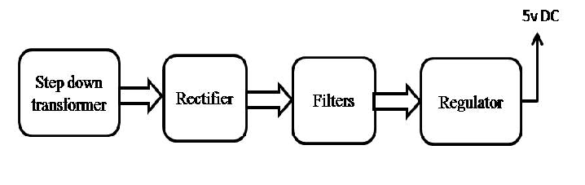
Block diagram:
