Automatic Power management with Bi-directional
Visitor counter
The objective of this project is to make a controller based model to count number of persons visiting particular room and display on the LCD. It also controls the loads using PIR based human sensor and electromagnetic relay.
In our project we use IR sensors to detect the presence of a person. According to this project, two IR sensors are placed apart with a fixed known distance. When ever IR rays are interrupted by a person during first sensor the count up timer is started. This count value is displayed on the LCD. If it is obtained at second sensor then the count will be decreases depending upon the crowd. It counts the visitors moving in both IN and OUT directions and resultant persons count gets displayed on LCD.
This project also makes use of PIR based human presence sensor inside a room and based on that it controls the room lights/load. In this way we can save the electrical power consumption.
Features:
- User-friendly interaction with the user.
- Highly sensitive
- Power will be conserved.
- Automatic Load control
- LCD displays live human count.

Regulated power supply:
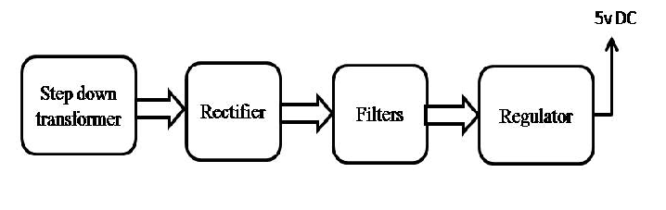

Block Diagram:

