ANDROID BASED OBJET PICK & PLACE ROBOT

In this project, we are using Bluetooth Module to control robot movements wirelessly. It can be controlled wirelessly using phone having Bluetooth support with Android Based Application Software. The Bluetooth module is interfaced with microcontroller ATMEGA328 which takes proper actions for the movements of two DC motors. These motors are interfaced with the microcontroller with the motor driver L293D circuit. Two more DC motors for robotic arm are interfaced with another L293D driver circuit. Depending upon the commands, the vehicle has movements such as Forward, Reverse, Left, Right, Stop, arm Up, Down, Open, Close etc. We are here using Android enabled mobile phone. We can also send live video streaming to PC or android device using Wi-FI connectivity.

Hardware Components:
- ATMEGA328
- Bluetooth Module
- L293 MOTOR DRIVER IC
- GEAR DC MOTORS
- RECHARGEABLE BATTERY 12V
Software:
- ARDUINO IDE
- EMBDDED CPP CODE
- PROTEUS SIMULATOR

Block Diagram :

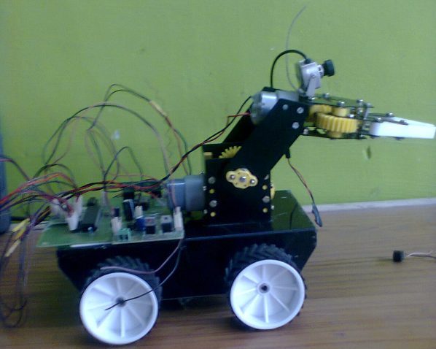

ATMEGA328
MCU
L293D MOTOR DRIVER
BLUETOOTH MODULE
GEAR
DC MOTORS

12 V Rechargeable Battery for power supply to all units

